Readings for Reflection
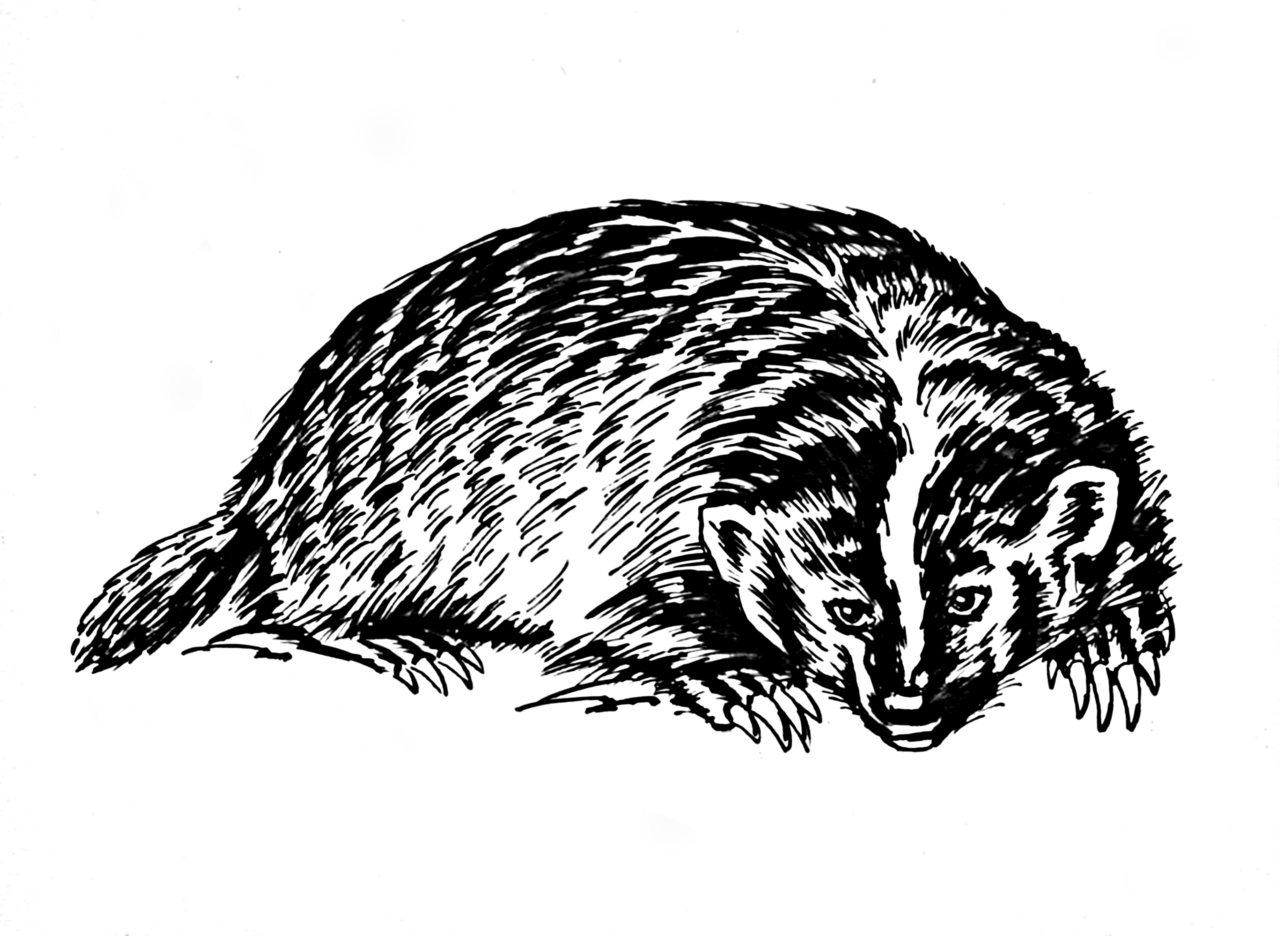

The animals of the world
exist for their own reasons.
They were not made for humans
any more than
black people were made for whites,
or women created for men.

---Alice Walker

Love all God’s creation,
the whole and every grain of sand of it.
Love every leaf, every ray of God’s light.
Love the animals, love the plants,
love everything.
If you love everything,
You will perceive the divine mystery in things.
Once you perceive it,
you will begin to comprehend it
Better every day.
And you will come at last
to love the whole world
With an all-embracing love.

~Fyodor Dostoyevsky
Readings for Reflection

The animals of the world
exist for their own reasons.
They were not made for humans
any more than
black people were made for whites,
or women created for men.

---Alice Walker

Love all God’s creation,
the whole and every grain of sand of it.
Love every leaf, every ray of God’s light.
Love the animals, love the plants,
love everything.
If you love everything,
You will perceive the divine mystery in things.
Once you perceive it,
you will begin to comprehend it
Better every day.
And you will come at last
to love the whole world
With an all-embracing love.

~Fyodor Dostoyevsky

